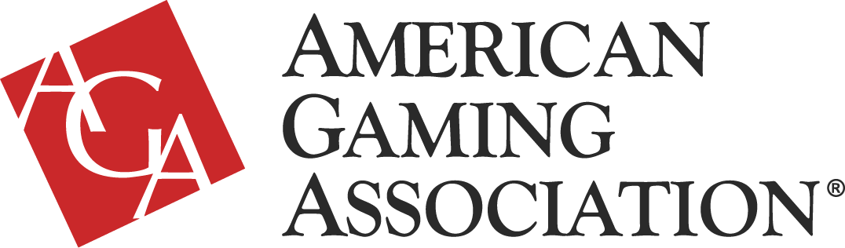
Recognizing September 19-25, 2021 as Responsible Gaming Education Week
WHEREAS, the [STATE/CITY/TOWN] casino gaming industry is an important part of the [STATE/CITY/TOWN], having contributed greatly to the [STATE/CITY/TOWN] economy and quality of life of our citizens by creating jobs, generating tax revenue to support [FILL IN WHAT TAX REVENUE GOES TO], and serving as a trusted community partner; and
WHEREAS, the gaming industry commits significant resources—both financial and people—to promote responsible gaming and combat problem gambling through employee training; consumer education, tools, and resources; and funding problem gambling services and research.
WHEREAS, in 1998, the American Gaming Association established Responsible Gaming Education Week to promote responsible gaming nationwide and to educate employees and customers on the subject.

WHEREAS, Responsible Gaming Education Week 2021—from September 19 to September 25— brings together the gaming industry, advocacy groups, regulators, and other key stakeholders to promote transparency and gaming literacy.
NOW, THEREFORE, I, [ELECTED OFFICIAL NAME/TITLE], do hereby proclaim September 19-25, 2021 as Responsible Gaming Education Week.

Given, this the [XX] day of September 2021.

__________________________________
[Elected Official Name/Title]

